Department of Mechanical Engineering
IIT Kharagpur

Allotment of M.Tech Project for 5Y DD ME-1 Students for Session 2026-27

Name of the student: Ayush Debnath

Roll number: 22ME31010

Name of the project supervisor: Prof. D.K. Pratihar

Broad area of the project to be carried out: Robotics

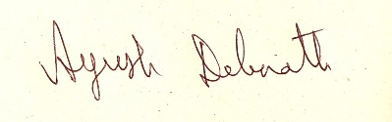

Signature of the supervisor Signature of the student
Date: Date: 11-05-26

---
Please send the filled-in form to drsankhadeb@gmail.com after signature.

